# Download FTP file using c#

You can download FTP file in c# application by using System.Net namespace.

Create one FTPRequest object to communicate with the server.



In this object, Add method type as ‘download file’. Assign network credentials to this request object. As shown below,



You can get response in the FtpWebResponse object from the request.

Finally, The method used to download the file will look like this,

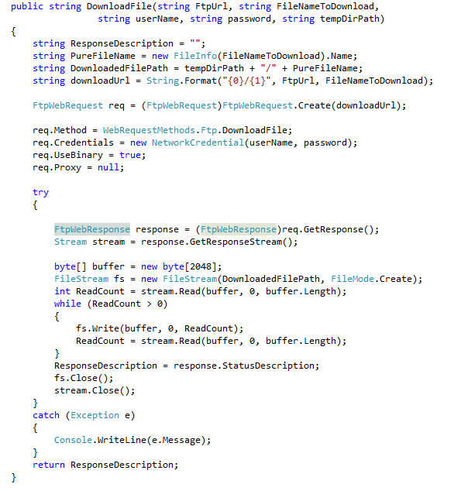

In response object, you can get the various property of Response object like, Headers, ResponseUri, StatusCode,StatusDescription and many more.

Here, I have get the StatusDescription of the response object as return type string.

So you can get the ftp file in your c# application with this simple method.